Maynooth International Engineering College

CS253FZ Computer Architecture 2
Class Test 1 2023
Q1. Study the block of 8086 assembly language code below and answer the following questions.
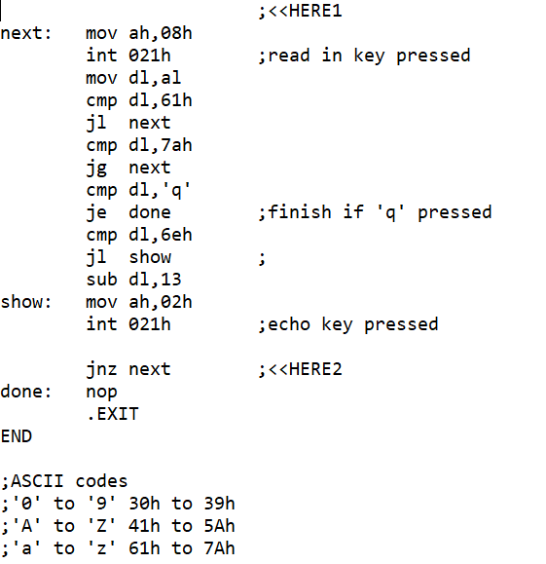
This block of code takes in some characters typed on the keyboard and displays the characters onto the screen.
- What will be displayed on the screen if “abc123XYZnop” is typed into the computer? (15 marks)
Ans: abcabc

- What will the program display if the string typed in is “xyz890PQRpqr” ? (10 marks)
Ans: klmc

- Add one instruction at location marked <<HERE1 and replace the instruction at <<HERE2 so that the code will display at most 8 characters, meaning that the program will exit the input loop after 8 characters even though the ‘q’ key is not pressed. (15 marks)
Ans: mov cx,8 <<HERE1
loop next <<HERE2
- With these changes, what will the program display if the string typed is “12345abcdXYZpqrs890” ? (10 marks)
Ans: abcdc

Q2. You are to write a block of code following the suggestions given below. The code will accept a string of decimal digits until <ret> is entered, and store them in BCD format in BX.

Label | Assembly code | marks
 | Clear BX for storing digits | (5 marks)
next: | Read in key pressed  If <ret> go to done  Check if it is a decimal digit | (10 marks)
 | If decimal digit, echo it  If not, ignore it, go back to next | (5 marks)
 | Put 4 into loop counter for 4 bits | (5 marks)
movnib: | Shift previous nibbles 4 bits left  Change new digit from ASCII to number  AND with new number  Loop back to next | (15 marks)
done: | Exit program

Ans:
Label | Assembly code | marks
 | mov bx,0 | (5 marks)
next: | mov ah,08h  int 021h ;read in key pressed  cmp al,13  je done ;finish if <ret> pressed  cmp al,030h  jb next ;jmp if below  cmp al,039h  jnb next ;jmp if not below | (10 marks)
 | mov dl,al  mov ah,02h  int 021h ;echo key pressed | (5 marks)
 | mov cx, 4 | (5 marks)
movnib: | shl bx,1  loop movnib ;shift number to higher nibble  and ax,0fh ;change ASCII to number  or bx,ax ;store digit  jmp next | (15 marks)
done: | Exit program

Give the hex value in BX if the following numbers are entered:
- 123 <ret> (5 marks)
Ans: 0123h
- 12345 <ret> (5 marks)
Ans: 2345h

[Total: 100 marks]

